GCFH-MDA: Graph Collaborative Filtering with Hypergraph Augmentation for miRNA-Drug Association Prediction
Ying Fu¹, Ru Nie^{1,*}, Zhengwei Li^{1,2,3} and Zhanguo Xia¹
¹ School of Computer Science and Technology, China University of Mining and Technology, Xuzhou 221116, China
² Big Data and Intelligent Computing Research Center, Guangxi Academy of Science, Nanning 530007, China
³ School of Artificial Intelligence, China University of Mining and Technology, Xuzhou 221116, China
Abstract. MicroRNAs (miRNAs) play a pivotal role in drug response regulation by modulating target gene expression. However, existing miRNA-drug association prediction methods still face challenges due to sparse interaction data and insufficient integration of biological priors. To address these issues, we propose GCFH-MDA, a graph collaborative filtering framework with hypergraph augmentation. The model formulates the task as collaborative filtering on a prior-guided bipartite interaction graph. To overcome sparsity, auxiliary hypergraphs are constructed from two complementary views: a regulatory view derived from miRNA-gene and drug-gene networks, and an embedding view based on sequence and structural features. Geodesic feature augmentation prioritizes biologically specific pathways, while contrastive learning aligns local and global representations within each view. Experiments on 8,720 known associations under five-fold cross-validation show that GCFH-MDA achieves 96.64% AUC and 96.04% AUPR, outperforming seven state-of-the-art baselines. This demonstrates the effectiveness of integrating biological priors and multi-view information for prioritizing miRNA-drug candidates.
Keywords: miRNA-drug association prediction, collaborative filtering, hypergraph representation learning, contrastive learning.
- Introduction
Cancer remains a leading cause of death worldwide, imposing a severe global health burden [1]. Although chemotherapy is a cornerstone of cancer treatment, the genetic and epigenetic evolution of tumor cells often drives drug resistance, leading to treatment failure and poor prognosis [2]. This resistance arises from complex mechanisms such as abnormal drug uptake, altered drug targets, dysregulated cell cycles, and enhanced DNA repair [3].
MicroRNAs (miRNAs), small non-coding RNAs of approximately 22 nucleotides, are pivotal post-transcriptional regulators in tumorigenesis and drug response. Increasing evidence shows that miRNAs modulate drug resistance through drug transporter regulation, DNA damage repair, apoptosis, EMT, and metastasis-related pathways [4]. Dysregulated miRNA expression contributes to tumor progression, while miRNA mimics and antagomiRs show therapeutic potential [5]. miRNAs can either promote or reverse chemoresistance; for example, miR-20a enhances cisplatin resistance in gastric cancer by targeting CYLD [6], whereas miR-200c reverses multidrug resistance in breast cancer via MDR1 suppression [7].
Although experimental approaches are essential for characterizing miRNA-drug regulatory mechanisms, they remain costly and time-consuming for large-scale screening. This has spurred the development of miRNA-drug association resources for computational prioritization. Databases such as NoncoRNA [8], ncRNADrug [9], and ncDR [10] provide curated associations and support data-driven MDA prediction.
Advances in high-throughput profiling and graph representation learning have promoted the application of graph neural networks (GNNs) in biomolecular interaction prediction [11]. Existing MDA methods can be broadly categorized into three groups. The first category focuses on integrating sequence and structural data. For example, DLST-MDA [12] fuses multi-scale CNNs with GCNs, while NASMDR [13] uses GIN-based drug encoders and k-mer miRNA embeddings optimized via neural architecture search. The second emphasizes GNN architecture innovations, including DMGAT [14] with diffusion-enhanced hybrid GCN-GAT modeling, DARSFormer [15] with spectral graph transformation and dynamic attention, and GraphTGI [16] for heterogeneous regulatory networks via graph attention and bilinear decoders. The third explores advanced learning paradigms, represented by SSLMCD [17], unifying attribute and topological graphs through self-supervised contrastive learning and multi-view attention for multi-task ncRNA association prediction.
Despite this progress, existing methods still face several limitations. First, known MDA associations are sparse, producing incomplete and noisy bipartite graphs. Second, miRNA-drug relationships are mediated by complex gene regulatory mechanisms that require multi-source biological knowledge. Third, although different biological modalities capture complementary macro- and micro-level information, many models still lack effective fusion and cross-modal alignment [18].
To address these challenges, we propose GCFH-MDA, a graph collaborative filtering framework integrating heterogeneous biological data with contrastive learning for intra-view alignment. Specifically, our contributions are:
- We formulate miRNA-drug association prediction as a prior-guided graph collaborative filtering problem, enabling modeling of both direct and high-order interaction patterns within a unified framework.
- We propose a dual-view hypergraph augmentation strategy that integrates regulatory and embedding information at both local and global scales, providing complementary structural and attribute-level representations.
- We introduce a geodesic feature refinement mechanism with hub-aware penalties to emphasize biologically meaningful paths and alleviate bias introduced by high-degree nodes.
- Material and Methods
This section outlines the data preparation and GCFH-MDA architecture (Fig. 1).
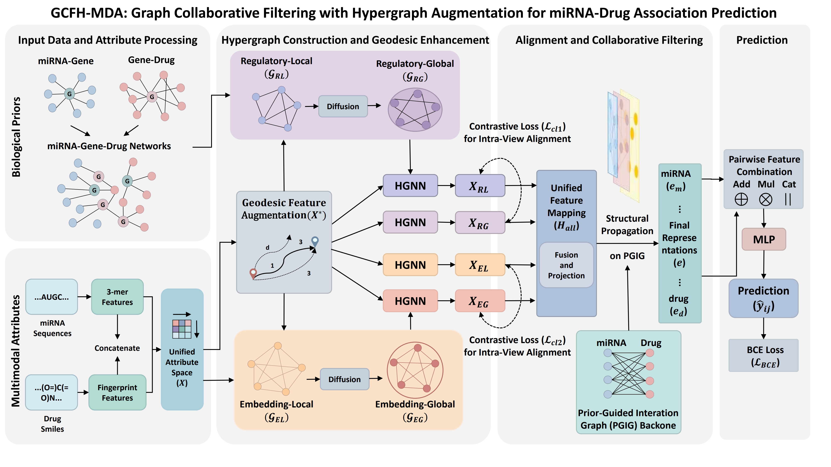
Fig. 1 Overview of GCFH-MDA.
  - Human miRNA-Drug Association Dataset
The benchmark was curated by Sheng et al. [18] from ncRNADrug [9], excluding deprecated miRNAs in miRBase v22 [19] and drugs with ambiguous DrugBank v5.1.12 annotations [20]. Mature miRNA sequences and drug SMILES were retrieved. The final dataset includes 8,720 validated associations between 1,578 miRNAs and 156 drugs. Additionally, miRNA-target and drug-target gene interactions were obtained from Sheng et al., encompassing 14,456 high-confidence interactions validated in miRTarBase [21] and the Comparative Toxicogenomics Database (CTD) [22].
  - Multimodal Node Attributes
MiRNA and drug features are encoded by mapping sequence and structural information into a shared $d$-dimensional space. MiRNA sequences are represented as normalized 3-mer frequency vectors [23], with cosine similarity forming the miRNA similarity matrix $S_{m}∈R^{N_{m}×N_{m}}$, where $N_{m}$ is the number of miRNAs. Drugs are encoded with Morgan fingerprints [24] from SMILES, and Tanimoto similarity constructs the drug structural similarity matrix $S_{d}∈R^{N_{d}×N_{d}}$, where $N_{d}$ is the number of drugs. Rows of $S_{m}$ and $S_{d}$ are used as initial node features, and learnable transformations $W_{m}$ and $W_{d}$ project them into a shared latent space:
$x_{m}^{i}=s_{m}^{i}⋅W_{m}, x_{d}^{j}=s_{d}^{j}⋅W_{d}$. (1)

where $s_{m}^{i}$ and $s_{d}^{j}$ denote the $i$-th and $j$-th rows of $S_{m}$ and $S_{d}$ respectively. These resulting embeddings are concatenated into a feature matrix $X∈R^{\left(N_{m}+N_{d}\right)×d}$.
  - Heterogeneous Graph: Regulatory and Embedding Views
As shown in Fig. 1, four hypergraphs are constructed from regulatory and embedding views, including local ($G_{RL}$, $G_{EL}$) and global ($G_{RG}$, $G_{EG}$) hypergraphs.
Local Hypergraph. To capture high-order neighborhood relations, two local hypergraphs are constructed [25]. In the regulatory view, $G_{RL}=(V,E_{RL})$ is built from top-$k_{g}$ gene-centered associations, where nodes sharing the same gene form a hyperedge, yielding incidence matrix $H_{RL}$. In the embedding view, $G_{EL}=(V,E_{EL})$ is constructed by connecting each node with its top-$k_{n}$ nearest neighbors in embedding space, producing incidence matrix $H_{EL}$.

Global Hypergraph. To model long-range dependencies, $G_{RG}$ and $G_{EG}$ are generated from $G_{RL}$ and $G_{EL}$ via the same symmetric residual diffusion mechanism. For each view, the initial structural association matrix is $S^{(0)}=H_{l}^{(v)}D_{e}^{-1}{{(H}_{l}^{(v)})}^{⊤}$, with symmetric diffusion iteratively defined as:
$S^{(k)}=αS^{(0)}+(1-α) ΘS^{(k-1)}$ (2)

where $Θ=D_{v}^{-1/2}S^{(0)}D_{v}^{-1/2}$ and $α∈(0,1)$ controls the contribution of the original structure [25]. After $K$-step diffusion, each node connects to its top-$k_{n}$ most similar nodes to form the global incidence matrix $H_{RG}$ and $H_{EG}$. Thus, local hypergraphs preserve fine-grained high-order associations, while global hypergraphs capture complementary long-range dependencies.
  - Feature Enhancement and Hypergraph Encoding

As shown in the feature enhancement module of Fig. 1, each hypergraph undergoes geodesic feature augmentation followed by hypergraph neural network encoding.

Geodesic Feature Augmentation. Following the generalized geodesic distance framework [27], we adapt it to hypergraph-based biological networks by introducing a hub-aware penalty to suppress nonspecific high-degree nodes and emphasize biologically meaningful paths. For each hypergraph $G_{v}∈\{G_{RL},G_{RG},G_{EL},G_{EG}\}$, geodesic features are obtained via a minimum-cost propagation process. We define a degree-based potential $ρ(i)$ to penalize paths through hubs:
$ρ(i)={\left(\frac{d(i)}{E[d]}\right)}^{γ}$ (3)
where $d(i)$ is the hyper-degree of $v_{i}$, $E[d]=\frac{1}{|V|}\sum_{i}{d}(i)$ is the average hyper-degree, and $γ$ is a specificity parameter. With scaling factor $β>0$, the generalized geodesic distance is updated as:
$f^{(t+1)}(i)=\left\{\begin{matrix}\min_{j∈N_{H}(i)}\left(f^{(t)}(j)\right) + βρ(i), & |N_{H}(i)|>0 \\ C_{max}, & |N_{H}(i)|=0\end{matrix}\right.$ (4)
where $N_{H}(i)$ contains nodes sharing at least one hyperedge with $v_{i}$, and $C_{max}$ applies to isolated nodes. Boundary nodes $B$ are defined as seed nodes incident to the core hyperedges used to initialize geodesic propagation. The initial state is:
$\begin{matrix}f^{(0)}(i)=\left\{\begin{matrix}0, & i∈B, \\ +∞, & otherwise\end{matrix}\right.\end{matrix}$ (5)
After convergence, $f_{v}(i)$ represents the geodesic distance from $B$ to $v_{i}$. For each view, normalized $f_{v}(i)$ is concatenated with node feature $x_{i}$ to form the augmented matrix $X_{v}^{*}$ with rows $x_{v,i}^{*}=[x_{i} || {\tilde{f}}_{v}(i)]$.

Hypergraph Representation Learning. We apply Hypergraph Neural Networks [28] to process the augmented features. The convolution at the $(l+1)$-th layer is:
$\begin{matrix}X_{v}^{(l+1)}=ϕ\left(D_{v}^{-1/2}H_{v}D_{e}^{-1}H_{v}^{⊤}D_{v}^{-1/2}X_{v}^{(l)}W_{v}^{(l)}\right)\end{matrix}$ (6)
where $H_{v}$ is the incidence matrix of $G_{v},D_{v}$and $D_{e}$ are node and hyperedge degree matrices, and $W_{v}^{(l)}$ is a learnable parameter. The four hypergraph branches yield:
${X_{RL}=HGNN(X_{RL}^{*},H_{RL}), X_{RG}=HGNN(X_{RG}^{*},H_{RG}), \atop X_{EL}=HGNN(X_{EL}^{*},H_{EL}), X_{EG}=HGNN(X_{EG}^{*},H_{EG}) }$ . (7)
  - Intra-View Alignment and Graph Collaborative Filtering
As shown in Fig. 1, regulatory and embedding views are aligned and refined through the Prior-Guided Interaction Graph (PGIG) backbone.

Intra-View Contrastive Learning. Contrastive learning is applied between local and global representations within both regulatory and embedding views. For each view $v∈\{RL,RG,EL,EG\}$, node embeddings are projected into a latent space via an MLP: $Z_{v}=MLP(X_{v})$. For paired views $(v,u)$, each node $i$ has a positive pair $(z_{i}^{v},z_{i}^{u})$ and negatives $(z_{i}^{v},z_{k}^{u})$ for $k≠i$. The symmetric InfoNCE loss is:
$\begin{matrix}L_{v,u}=-\frac{1}{2N}\sum_{i=1}^{N}{\sum_{(a,b)∈\{(v,u),(u,v)\}}{\log{\frac{\exp{(}sim(z_{i}^{a},z_{i}^{b})/τ)}{\sum_{k=1}^{N}{\exp{(}}sim(z_{i}^{a},z_{k}^{b})/τ)}}}}\end{matrix}$ . (8)
where $N$ is the number of nodes, $sim(⋅)$ is cosine similarity function, and $τ$ is a temperature hyperparameter. We define two contrastive losses: $L_{cl1}$ for the regulatory perspective and $L_{cl2}$ for the embedding perspective.

Inter-Space Fusion and PGIG Backbone Refinement. To integrate heterogeneous signals, local and global representations within each perspective are first concatenated: $H_{R}=[X_{RL} || X_{RG}]$, $H_{E}=[X_{EL} || X_{EG}]$. We then apply MLP transformations to project them into a shared latent space: ${\tilde{H}}_{R}={MLP}_{g}(H_{R}),{\tilde{H}}_{E}={MLP}_{E}(H_{E})$, and the unified feature matrix is $H_{all}=[{\tilde{H}}_{R} || {\tilde{H}}_{E}]$.
Known miRNA-drug associations are encoded as a bipartite Prior-Guided Interaction Graph (PGIG). Let $Y∈\{0,1\}^{N_{m}×N_{d}}$ denote the observed miRNA-drug association matrix. The PGIG adjacency matrix is defined by the block matrix: $A=\left[\begin{matrix}0 & Y \\ Y^{⊤} & 0\end{matrix}\right]∈R^{(N_{m}+N_{d})×(N_{m}+N_{d})}$. To refine node representations, we adopt a collaborative filtering backbone with LightGCN propagation [29]. Specifically, we apply symmetric degree normalization: $\tilde{A}=D^{-1/2}AD^{-1/2}$, where $D$ is the degree matrix of $A$. Starting from $E^{(0)}=H_{all}$, propagation is defined as:
$E^{(l+1)}=\tilde{A}E^{(l)}$ (9)
Following LightGCN, we obtain the final representation by averaging embeddings from all layers to capture high-order collaborative signals:
$E_{final}=\frac{1}{L+1}\sum_{l=0}^{L}{E^{(l)}}$ (10)
  - Prediction of Potential miRNA-Drug Associations
To capture complex interaction patterns between a given miRNA-drug pair $(m_{i},d_{j})$, we extract their final representations $e_{m_{i}}$ and $e_{d_{j}}$ and form a pairwise feature vector $p=[e_{m_{i}} || e_{d_{j}}]$. The association probability ${\hat{y}}_{ij}$ is estimated as ${\hat{y}}_{ij}=σ(MLP(p))$ via a layer MLP. The final loss function is:
$L_{total}=L_{BCE}+λ_{1}L_{cl1}+λ_{2}L_{cl2}$ (11)
where $L_{BCE}$ is the binary cross-entropy loss between predicted scores ${\hat{y}}_{ij}$ and labels. Parameters $λ_{1}$ and $λ_{2}$ weight the contrastive losses.
- Results
Experiments were conducted under five-fold cross-validation to evaluate GCFH-MDA, including baseline comparisons, ablation, hyperparameter sensitivity, cold-start evaluation, and case studies. The model was implemented in Python 3.8 and PyTorch v2.1.0 with CUDA on an NVIDIA RTX 4090 GPU. Adam was used with learning rate 0.001, batch size 128, and training for 40 epochs.
  - Evaluation Metrics
Verified miRNA-drug associations were treated as positives, with an equal number of negatives sampled from unknown pairs. Performance was assessed using Precision, Accuracy, Recall, F1-score, AUC, and AUPR. In each fold, the PGIG was constructed from training data only. As shown in Table 1, GCFH-MDA achieved an average AUC of 96.64% ± 0.26 and AUPR of 96.04% ± 0.34.
Table 1. Performance of GCFH-MDA under five-fold cross-validation.
Fold | AUC(%) | AUPR(%) | Precision(%) | Accuracy(%) | Recall(%) | F1-score(%)
1 | 96.37 | 95.76 | 87.04 | 90.39 | 93.77 | 90.67
2 | 96.57 | 95.75 | 86.09 | 91.25 | 96.35 | 91.72
3 | 97.13 | 96.66 | 90.59 | 91.42 | 92.29 | 91.35
4 | 96.61 | 95.86 | 89.05 | 91.33 | 93.67 | 91.44
5 | 95.51 | 96.12 | 88.79 | 91.56 | 94.19 | 91.98
Mean | 96.64±0.26 | 96.04±0.34 | 88.95±1.71 | 91.19±0.42 | 94.05±1.42 | 91.43±0.47
  - Comparison with State-of-the-Art Methods
GCFH-MDA was compared with seven representative methods (DLST-MDA [12],
NASMDR [13], DMGAT [14], DARSFormer [15], GraphTGI [16], SSLMCD [17], and MGCNA [18]) under five-fold cross-validation. All baselines were re-trained using official codes. As shown in Fig. 2, GCFH-MDA achieves the best performance on most metrics, improving AUC and AUPR by 0.70% and 0.85% over SSLMCD with statistically significant gains (p < 0.05). These improvements benefit from integrating biological priors, multimodal information, and geodesic augmentation.
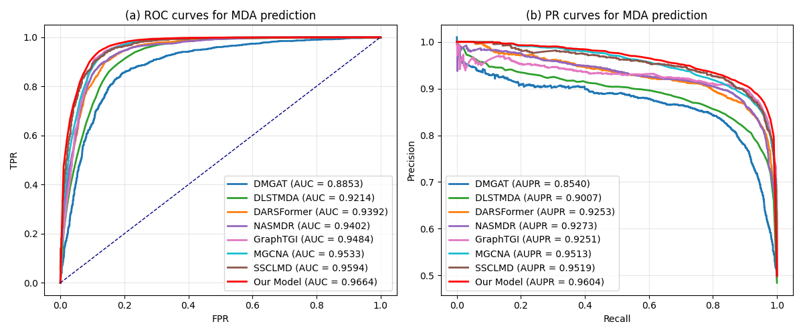
Fig. 2 Performance comparison of GCFH-MDA with baseline methods.
  - Ablation Study
Ablation experiments were conducted to assess the contribution of each component. As shown in Fig. 3, the full model is compared with several degraded variants:
- w/o Reg. Removing the regulatory hypergraph reduces AUC to 96.04% ($↓$0.60%), showing the contribution of gene-mediated priors.
- w/o Emb. Eliminating the embedding hypergraph lowers AUC to 95.47% ($↓$1.07%), indicating complementary patterns captured by multimodal attributes.
- w/o Global. Removing global structures and intra-view alignment decreases AUC to 96.03% (↓0.61%), reflecting the benefit of higher-order relations.
- w/o Geo. Without geodesic feature augmentation, the AUC drops to 96.11% ($↓$0.53%), showing its effectiveness in alleviating structural sparsity.
- w/o Prop. Removing the graph CF propagation causes a significant drop (AUC: 94.51%, $↓$2.13%), highlighting the central role of collaborative filtering.
Overall, all components contribute positively, while the significant drop without propagation confirms graph collaborative filtering as the core module, with other components providing complementary gains.
  - Hyperparameter Sensitivity Analysis
We evaluated GCFH-MDA under key hyperparameters, including the number of core genes $k_{g}$, hyperedge scale $k$, diffusion coefficient $α$, geodesic weight $β$, contrastive temperature $τ$, propagation depth $L$, and contrastive loss weights $λ_{1},λ_{2}$.
As shown in Fig. 4 and Fig. 5, the model maintains stable AUC and AUPR across a wide range of settings. Optimal performance is achieved at $k_{g}=500$, $k=10$, $α=0.7$, $β=1.0$, $τ=0.5$, $L=3$, and moderate contrastive weights ($λ_{1}=0.1$, $λ_{2}=0.5$). Results indicate embedding-based contrastive learning provides stronger regularization than regulatory view, while structural propagation and geodesic augmentation improve representations without over-smoothing.
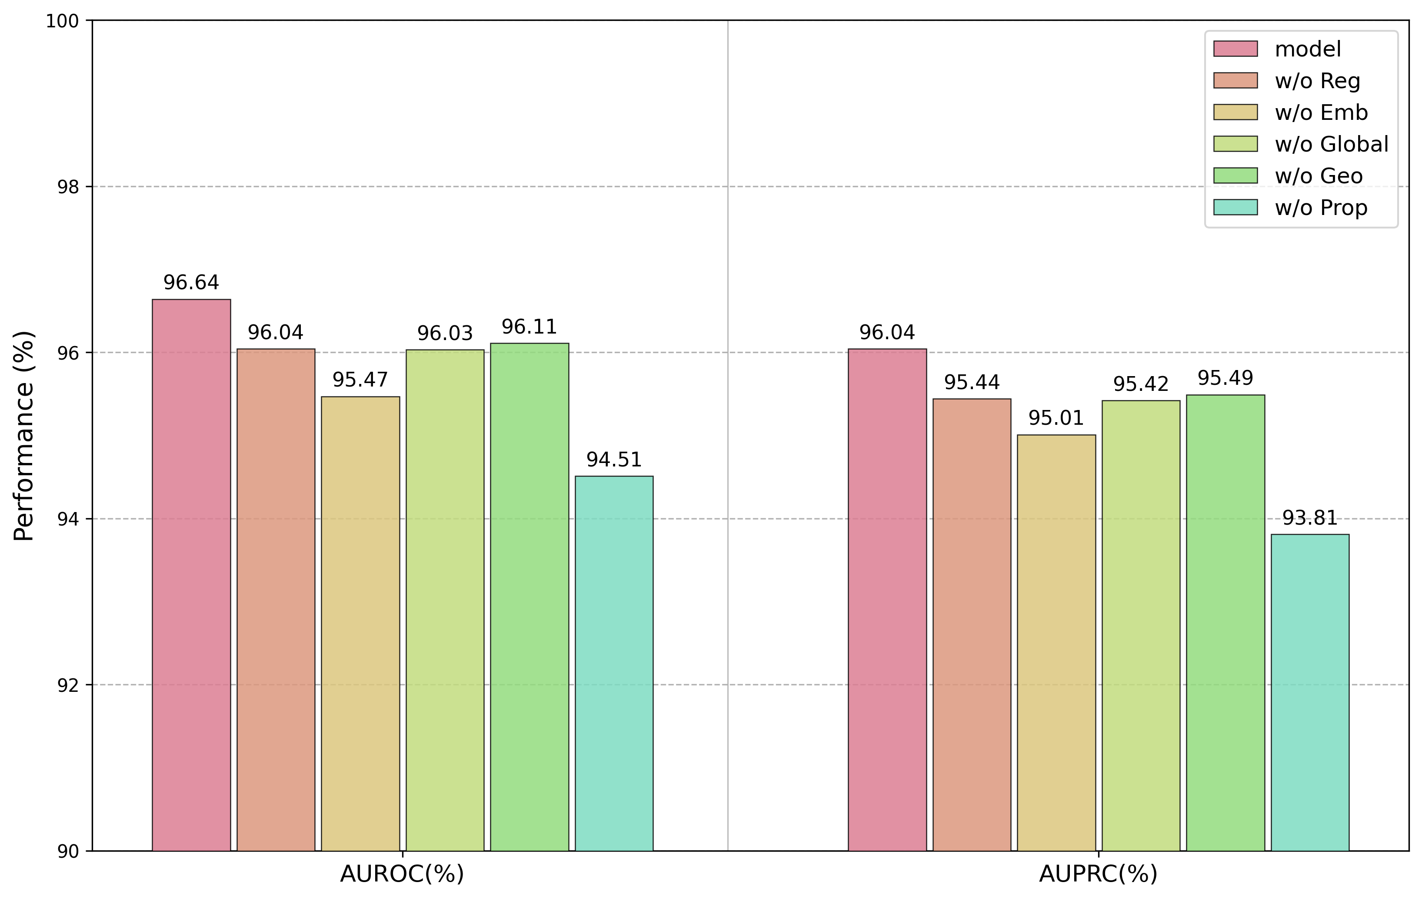
Fig. 3 Ablation study of GCFH-MDA.
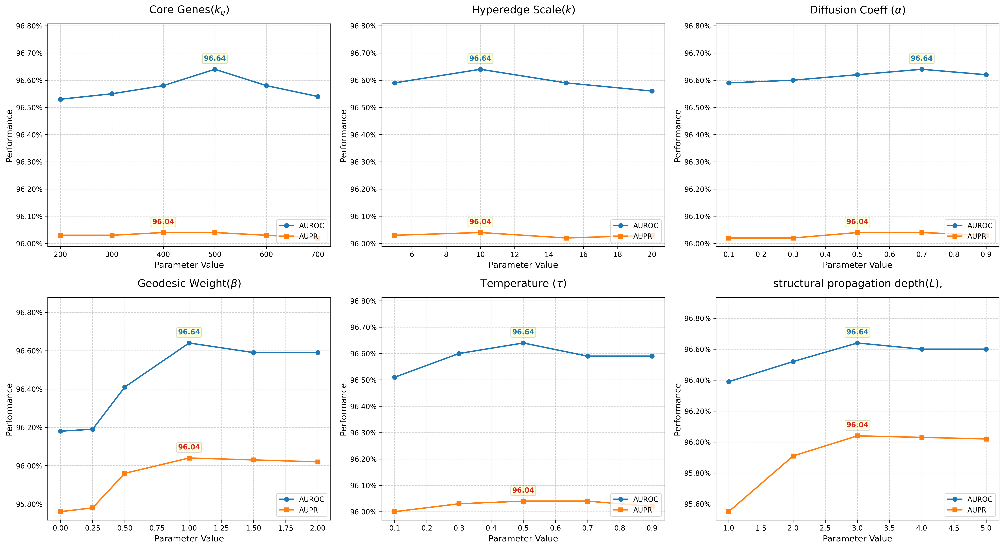
Fig. 4 Hyperparameter sensitivity analysis of GCFH-MDA.
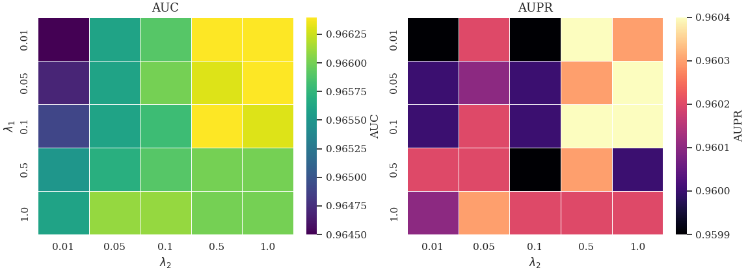  Fig. 5 Loss weight sensitivity analysis of GCFH-MDA | 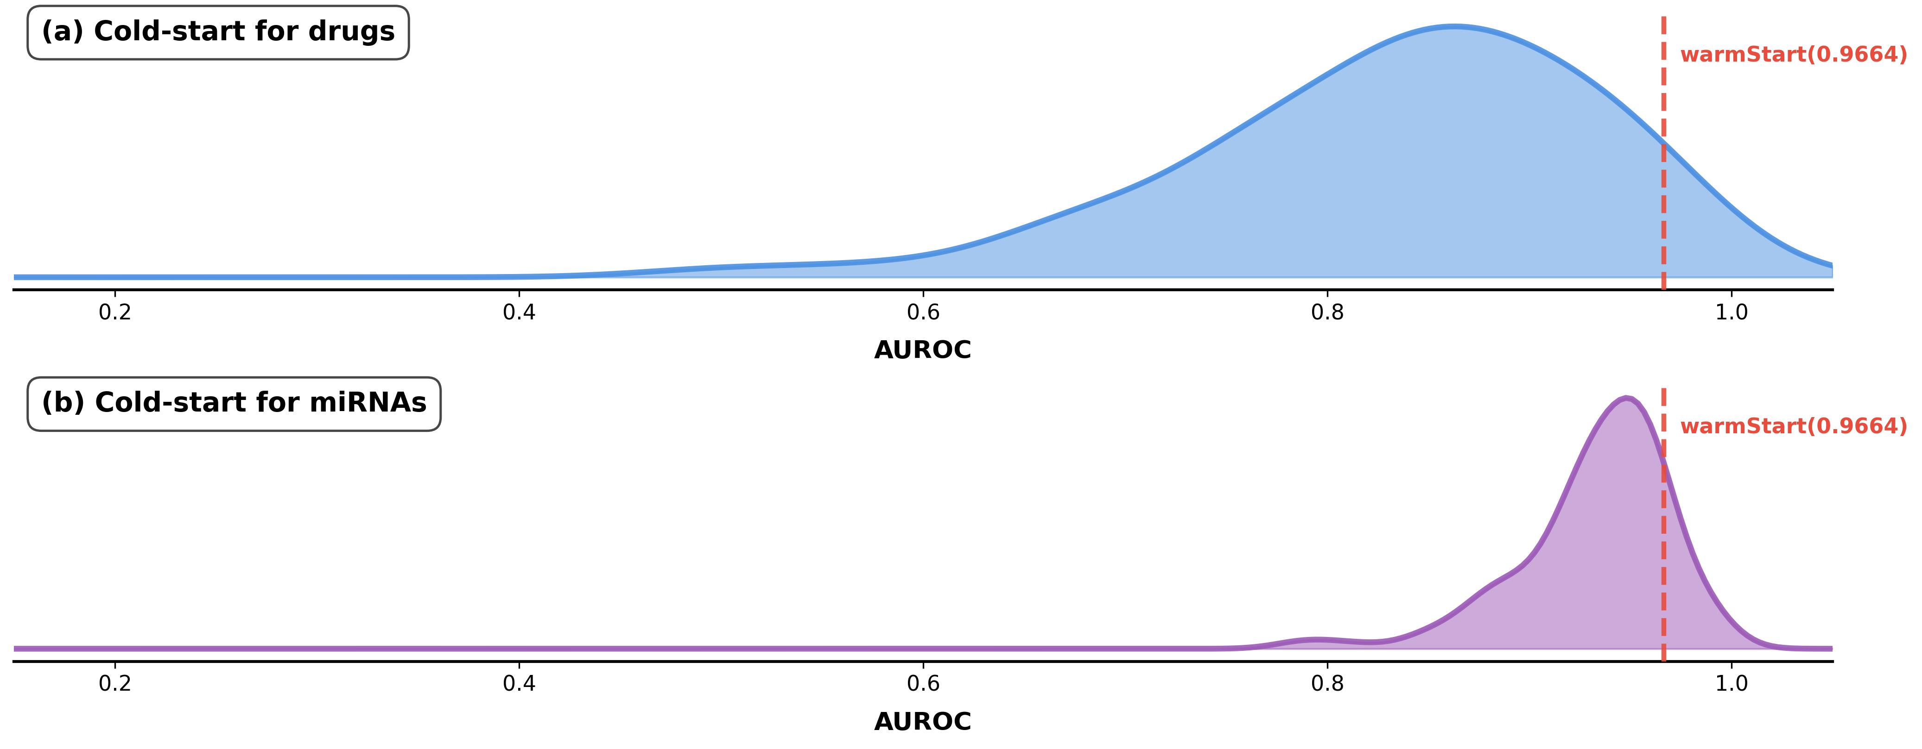  Fig. 6 Cold-start performance of GCFH-MDA
  - Performance in Cold-Start Scenarios
We further evaluate GCFH-MDA under cold-start settings: (i) drug cold-start and (ii) miRNA cold-start, where all associations of a held-out node are excluded for testing. The model is trained on remaining associations and evaluated on withheld interactions. As shown in Fig. 6, drug cold-start yields a broader AUC distribution (83.34%±9.83), while miRNA cold-start shows a narrower distribution (93.73%±3.98). These results support the framework’s effectiveness in cold-start prediction, particularly for emerging miRNAs and novel drugs.
  - Case Studies
To evaluate GCFH-MDA for prioritizing novel miRNA-drug associations, we conducted case studies on Fluorouracil, Cisplatin, and Doxorubicin. Using all known associations for training, the top-15 predicted miRNAs per drug were ranked by probability. As shown in Fig. 7, 7 candidates for 5-FU and Cisplatin, and 6 for Doxorubicin, are supported by literature [30-32]. These results demonstrate GCFH-MDA effectively identifies biologically relevant associations and may support drug resistance analysis and personalized treatment.
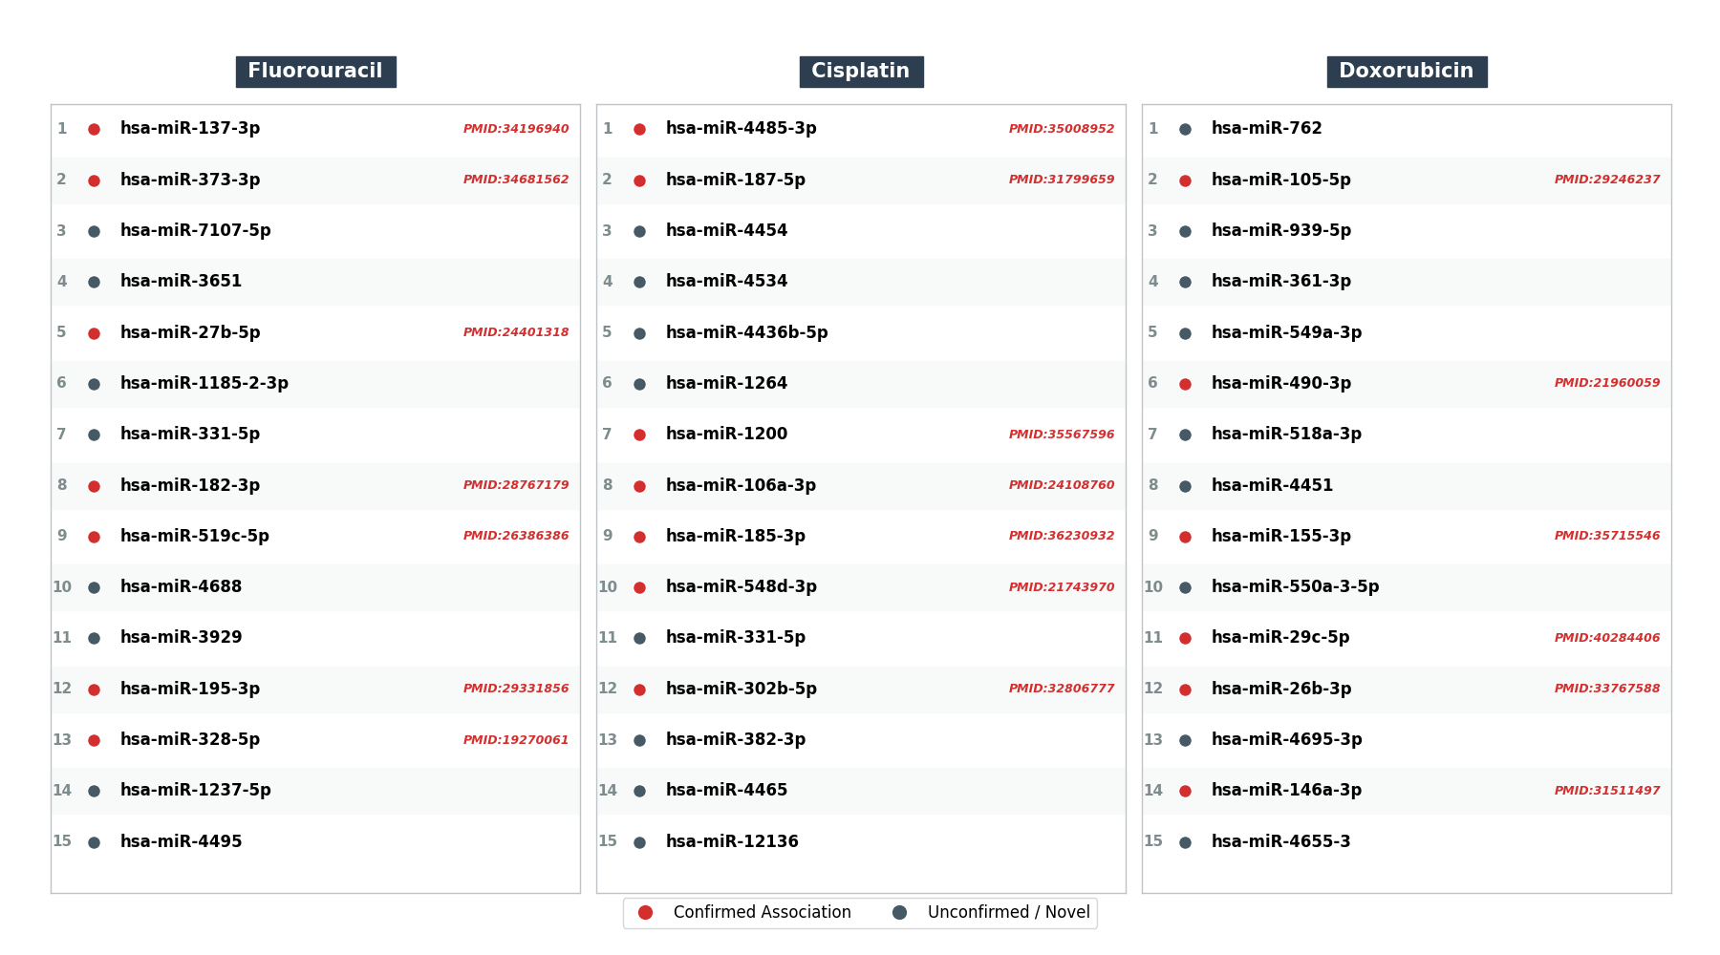
Fig. 7 Top 15 predicted miRNA-drug associations (not in the benchmark database) for Fluorouracil, Cisplatin, and Doxorubicin.
- Conclusion
Drug response variability influenced by miRNAs is critical for therapeutic outcomes, making accurate identification of miRNA-drug associations essential for studying drug resistance and precision medicine. We proposed GCFH-MDA, a graph collaborative filtering framework with hypergraph augmentation that integrates biological priors and multimodal attributes. Contrastive learning and geodesic augmentation enhance representation learning, achieving state-of-the-art AUC and AUPR on 8,720 associations, further supported by case studies on Fluorouracil, Cisplatin, and Doxorubicin. Future work will incorporate multi-omics and temporal data and experimentally validate mechanisms for personalized cancer therapy.
Acknowledgments. This work was supported by the National Natural Science Foundation of China under Grant 62472425, in part by the Natural Science Foundation of Guangxi Zhuang Autonomous Region under Grant 2024GXNSFAA010282.
Disclosure of Interests. The authors declare that they have no known competing financial interests or personal relationships that could have appeared to influence the work reported in this paper.

References
- Bray, F., et al.: The Ever-Increasing Importance of Cancer as a Leading Cause of Premature Death Worldwide. Cancer 127(16), 3029-3030 (2021)
- Long, L., et al.: Genetic Biomarkers of Drug Resistance: A Compass of Prognosis and Targeted Therapy in Acute Myeloid Leukemia. Drug Resistance Updates 52, 100703 (2020)
- Gottesman, M.M.: Mechanisms of Cancer Drug Resistance. Annual Review of Medicine 53(1), 615-627 (2002)
- Wei, L., et al.: Noncoding RNAs in Gastric Cancer: Implications for Drug Resistance. Molecular Cancer 19(1), 62 (2020)
- Takahashi, R.U., et al.: Development of miRNA-based therapeutic approaches for cancer patients. Cancer Science 110(4), 1140-1147 (2019)
- Zhu, M., et al.: miR-20a induces cisplatin resistance of a human gastric cancer cell line via targeting CYLD. Molecular Medicine Reports 14(2), 1742-1750 (2016)
- Safaei, S., et al.: miR-200c Increases the Sensitivity of Breast Cancer Cells to Doxorubicin through Downregulating MDR1 Gene. Experimental and Molecular Pathology 125, 104753 (2022)
- Li, L., et al.: NoncoRNA: A Database of Experimentally Supported Non-Coding RNAs and Drug Targets in Cancer. Journal of Hematology & Oncology 13(1), 15 (2020)
- Cao, X., et al.: ncRNADrug: A Database for Validated and Predicted ncRNAs Associated with Drug Resistance and Targeted by Drugs. Nucleic Acids Research 52(D1), D1393-D1399 (2024)
- Dai, E., et al.: ncDR: A Comprehensive Resource of Non-coding RNAs Involved in Drug Resistance. Bioinformatics 33(24), 4010-4011 (2017).
- Wu, Z., et al.: A Comprehensive Survey on Graph Neural Networks. IEEE Transactions on Neural Networks and Learning Systems 32(1), 4-24 (2021)
- Sheng, N., Liu, Y., Gao, L., et al.: Deep-Learning-Based Integration of Sequence and Structure Information for Efficiently Predicting miRNA-Drug Associations. Journal of Chemical Information and Modeling 65(11), 5317-5326 (2025)
- Zheng, K., et al.: NASMDR: A Framework for miRNA-Drug Resistance Prediction Using Efficient Neural Architecture Search and Graph Isomorphism Networks. Briefings in Bioinformatics 23(5) (2022).
- Liu, T., et al.: DMGAT: Predicting ncRNA-Drug Resistance Associations Based on Diffusion Map and Heterogeneous Graph Attention Network. Briefings in Bioinformatics 26(2) (2025).
- Li, Z., et al.: Predicting miRNA-Disease Associations Based on Spectral Graph Transformer with Dynamic Attention and Regularization. IEEE Journal of Biomedical and Health Informatics 28(12), 7611-7622 (2024)
- Du, Z.-H., et al.: GraphTGI: An Attention-Based Graph Embedding Model for Predicting TF-Target Gene Interactions. Briefings in Bioinformatics 23(3) (2022).
- Huang, L., et al.: Self-Supervised Contrastive Learning on Attribute and Topology Graphs for Predicting Relationships Among lncRNAs, miRNAs and Diseases. IEEE Journal of Biomedical and Health Informatics 29(1), 657-668 (2025)
- Sheng, N., Liu, Y., Gao, L., et al.: Multi-view fusion based on graph convolutional network with attention mechanism for predicting miRNA related to drugs. PLOS Computational Biology 11, e1013703 (2025)
- Kozomara, A., Birgaoanu, M., Griffiths-Jones, S.: miRBase: from microRNA sequences to function. Nucleic Acids Research 47(D1), D155-D162 (2019)
- Knox, C., et al.: DrugBank 6.0: the DrugBank Knowledgebase for 2024. Nucleic Acids Research 52(D1), D1265-D1275 (2024)
- Cui, S., et al.: miRTarBase 2025: updates to the collection of experimentally validated microRNA-target interactions. Nucleic Acids Research 53(D1), D147-D156 (2025).
- Davis, A.P., et al.: Comparative Toxicogenomics Database (CTD): update 2023. Nucleic Acids Research 51(D1), D1257-D1262 (2023).
- Li, M., et al.: Using Sequence Similarity Based on CKSNP Features and a Graph Neural Network Model to Identify miRNA-Disease Associations. Genes 13(10), 1759 (2022).
- Landrum, G.: Fingerprints in the RDKit. https://www.rdkit.org/, last accessed 2025/02/25 (2012)
- Li, M., Yang, Y., Meng, L., et al.: Self-supervised Hypergraph Structure Learning. Artificial Intelligence Review 58, 190 (2025)
- Gasteiger, J., Bojchevski, A., Günnemann, S.: Predict then Propagate: Graph Neural Networks meet Personalized PageRank. In: International Conference on Learning Representations (ICLR) (2019)
- Azad, A., Fang, Y.: A Learned Generalized Geodesic Distance Function-Based Approach for Node Feature Augmentation on Graphs. In: Proceedings of the 30th ACM SIGKDD Conference on Knowledge Discovery and Data Mining (KDD) (2024)
- Feng, Y., You, H., Zhang, Z., Ji, et al.: Hypergraph Neural Networks. In: AAAI (2019)
- He, X., Deng, K., Wang, X., Li, et al.: LightGCN: Simplifying and Powering Graph Convolution Network for Recommendation. In: Proceedings of the 43rd International ACM SIGIR Conference on Research and Development in Information Retrieval, pp. 639-648 (2020)
- van der Sijde, F., Homs, M.Y.V., et al.: Serum miR-373-3p and miR-194-5p Are Associated with Early Tumor Progression during FOLFIRINOX Treatment in Pancreatic Cancer Patients: A Prospective Multicenter Study. International Journal of Molecular Sciences 22(20), 10902 (2021)
- Ding, Y., et al.: Regulation Networks of Non-Coding RNA-Associated ceRNAs in Cisplatin-Induced Acute Kidney Injury. Cells 11(19), 2971 (2022)
- Fan, H., et al.: LncRNA LINC00173 enhances triple-negative breast cancer progression by suppressing miR-490-3p expression. Biomedicine & Pharmacotherapy 125, 109987 (2020)

